📘 Project Documentation

# Project Title:

Education Organization – Student Admission and Progress Tracking System

# Developer Name:

Sharief Sk

# Department / Institution:

Department of Computer Science and Engineering (Ideal Institute of Technology)

# Guidance:

In collaboration with SmartInternz and ServiceNow

# Date of Submission:

20/10/2025

# Acknowledgment

I would like to express my sincere gratitude to SmartInternz and ServiceNow for providing me the opportunity to work on this project under the ServiceNow Virtual Internship Program.

I am deeply thankful to my mentors, coordinators, and instructors who guided me throughout the internship and helped me understand the power of low-code development platforms in solving real-world problems.  
  
This project enhanced my technical knowledge and problem-solving skills while giving me hands-on experience with ServiceNow Studio, Flow Designer, and Client Script configurations.

I would also like to extend special thanks to my institution and faculty for their continued encouragement. Finally, I thank my family and friends for their consistent motivation and support during the entire project duration.

# Abstract / Executive Summary

The Education Organization – Student Admission and Progress Tracking System is a comprehensive ServiceNow-based application designed to streamline academic data management for educational institutions.

It digitizes the manual processes involved in student admission, course registration, and progress tracking. The system is implemented using ServiceNow’s low-code tools such as Flow Designer, Client Scripts, and Table Configurations.

This project introduces three main tables – Salesforce, Admission, and Student Progress – each serving a unique function in the system. Through automation, form validation, and process workflows, the project ensures real-time data integrity and accuracy. It exemplifies how ServiceNow can be utilized to build scalable and automated enterprise-level educational solutions.

# Introduction

In the modern educational landscape, managing student admissions and tracking academic progress manually is time-consuming, error-prone, and inefficient.   
Educational institutions require an integrated solution that can handle vast amounts of data while automating repetitive administrative tasks.  
  
The Education Organization project provides a streamlined digital workflow for managing students’ academic records and admission processes using the ServiceNow platform.   
It helps administrators automate approvals, data validation, and record generation without requiring complex programming.  
  
**Objectives of the project include:**  
- Automating admission data entry and validation using Client Scripts.  
- Implementing Flow Designer to streamline admission workflows.  
- Designing relational tables to manage Salesforce leads, admission details, and student performance data.  
- Utilizing Number Maintenance to auto-generate unique student identifiers.

The project’s scope covers the complete implementation cycle — from table design and user interface configuration to workflow automation and testing.   
This system can be scaled and enhanced to manage additional modules such as faculty data, attendance, and result analytics.

# Literature Review / Existing System

Existing student information systems often depend on traditional software or manual record-keeping, which results in inefficiency and limited automation.   
Conventional applications lack dynamic form validation, automated data population, and process flow integration.

ServiceNow, being a cloud-based platform-as-a-service (PaaS), offers an ideal environment to implement such solutions.   
It supports rapid application development using built-in features such as Client Scripts, Flow Designer, and ACLs without requiring deep coding expertise.  
  
The Education Organization project utilizes these capabilities to overcome the limitations of older systems by providing automation, consistency, and scalability.

# Proposed System / Project Overview

The proposed system digitizes the student admission and academic tracking process by leveraging ServiceNow’s application development features.  
The system architecture consists of three primary modules: Salesforce, Admission, and Student Progress.  
Each module represents a table within the ServiceNow database and is interconnected through flows and automation rules.  
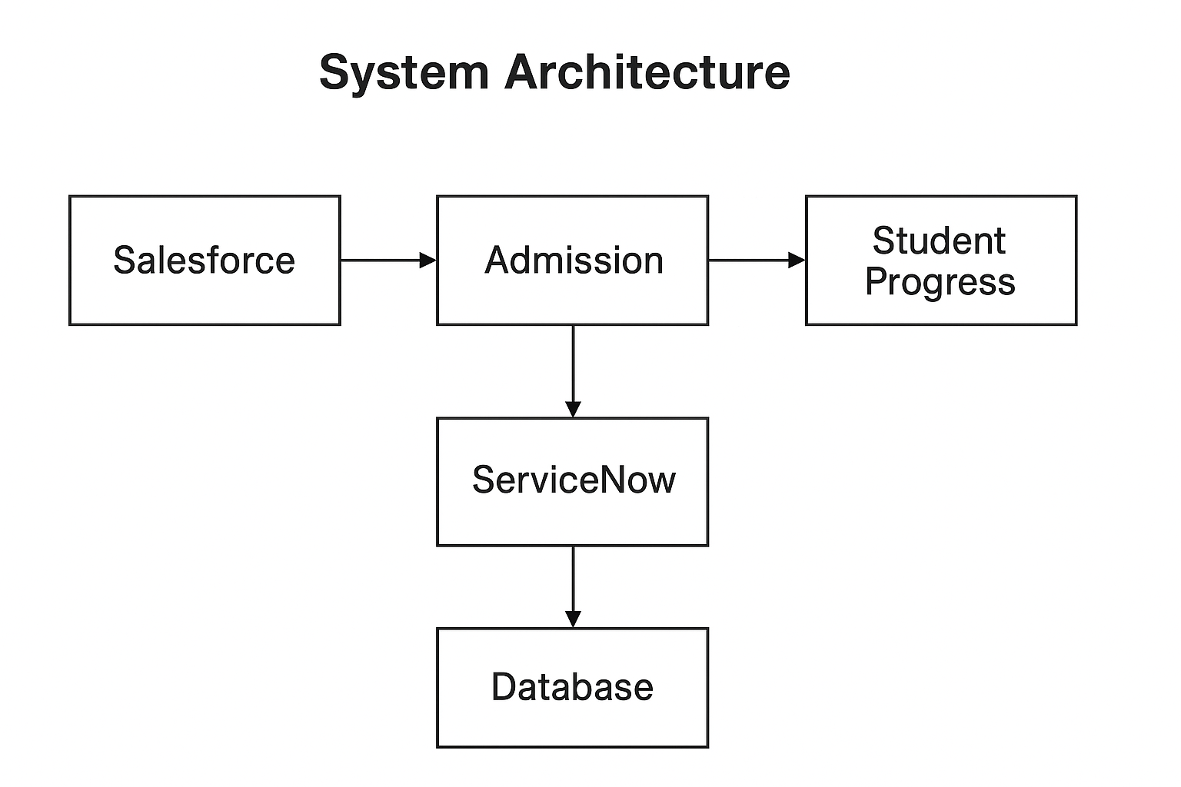

**Key Features:**  
- Modular design for Salesforce, Admission, and Student Progress tables.  
- Form designs configured for data entry and validation.  
- Client Scripts for automating calculations, validations, and field manipulations.  
- Flow Designer for automating approval and admission workflows.  
- Number Maintenance to generate unique identifiers for each student.

**Advantages of the Proposed System:**  
- Reduces human errors in data entry.  
- Enhances operational efficiency through automation.  
- Ensures data accuracy and consistency.  
- Provides real-time insights into student performance.

# System Design

The system design defines the data structure, user interface, and workflow automation for the project.  
It follows a modular and scalable architecture with well-defined relationships between tables.  
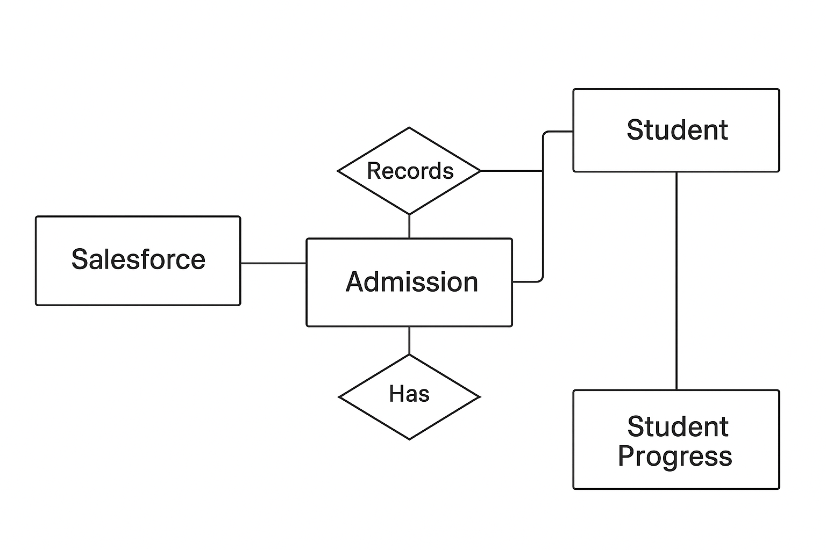

**Modules:**  
1. Salesforce: Captures leads and student contact information.  
2. Admission: Stores student admission details and manages validation.  
3. Student Progress: Tracks performance, results, and percentage calculations.  
  
**Data Flow:**  
- Data from Salesforce is moved to Admission once a student’s record is verified.  
- Upon admission confirmation, Student Progress is automatically updated via Flow

# Implementation

The implementation phase involved configuring ServiceNow Studio to create the Education Organization application.   
Three tables—Salesforce, Admission, and Student Progress—were developed with corresponding form designs and related lists.

**Client Scripts Implemented:**  
1. Auto Populate Script – Prefills data based on previous records.  
2. Pincode Validation – Verifies entered pin codes and populates city/state details.  
3. Disable Fields Script – Disables certain fields when conditions are met.  
4. Total Update Script – Automatically calculates total marks.  
5. Result and Percentage Script – Determines results dynamically based on input.

**Process Flow**:  
The Admission Process Flow manages the stages from application submission to verification and confirmation.

**Number Maintenance:**  
Configured to assign unique identifiers (Admin Numbers) to each student, ensuring record uniqueness.

# Testing

Testing ensures all configurations and scripts function correctly. The system underwent several testing phases including:  
- Unit Testing: Verification of individual client scripts and flows.  
- Integration Testing: Ensured smooth data transfer between Admission and Student Progress tables.  
- System Testing: Full workflow testing from admission entry to result update.

# Results and Discussion

The project successfully automated the student admission and progress tracking process.   
Client scripts executed accurately, and process flows triggered without manual intervention.  
The data consistency and validation mechanisms significantly improved administrative accuracy.

# Applications and Use Cases

- Educational Institutions: Manage admissions and track academic records.  
- Coaching Centers: Track student performance and generate progress reports.  
- Universities: Integrate student data with existing ServiceNow ITSM modules.

# Conclusion

The Education Organization System effectively demonstrates how ServiceNow’s platform can be used to create dynamic, low-code business applications.  
It reduces manual workload, minimizes errors, and introduces efficiency in academic record management.   
This project deepened my understanding of process automation, database relationships, and scripting in ServiceNow.

# Future Scope

- Integration with Service Portal for student self-service.  
- Additional modules such as Faculty, Courses, and Attendance.  
- Advanced dashboards using Performance Analytics.  
- AI integration for predictive student performance analysis.

# References / Bibliography

1. ServiceNow Developer Documentation – https://developer.servicenow.com  
2. GitHub – https://github.com/Sk-Sharief/Educational-Organization-Using-ServieNow  
3. Demo Video Link: https://drive.google.com/file/d/1bCzBYc0ESXZxIBt-dUwunxVR5fA4zuWO/view

# Project Pics

**PROBLEM:**

To facilitate efficient management of students and Teacher data, simplifies the admission process, and provides tools for monitoring student progress.

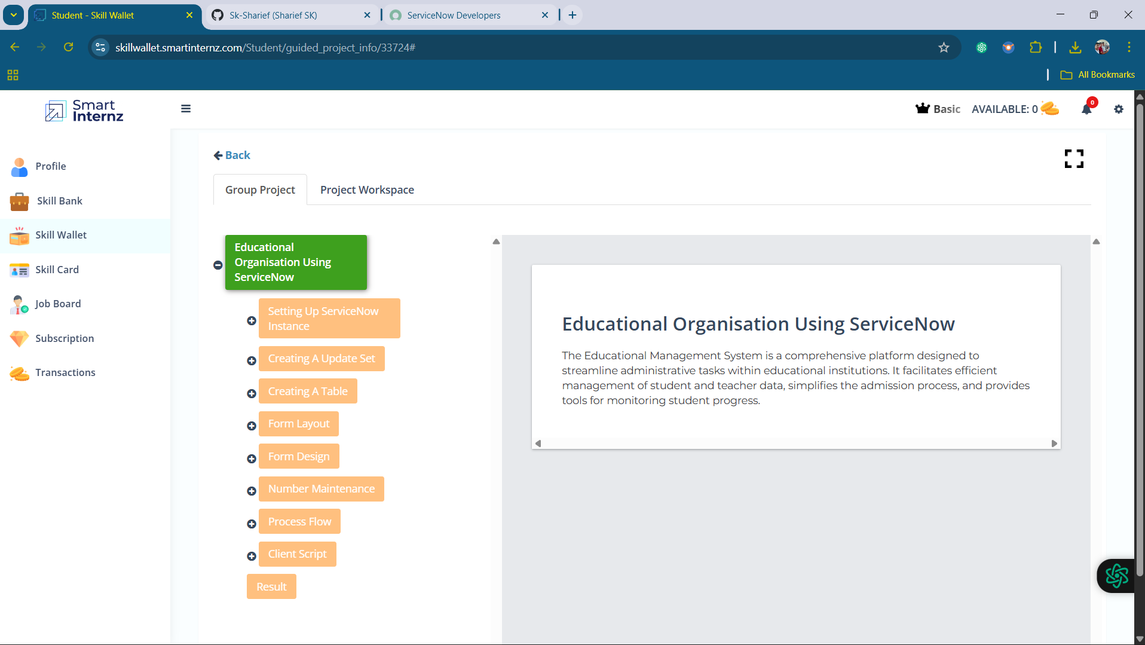

**PROCESS:**

1.Start building

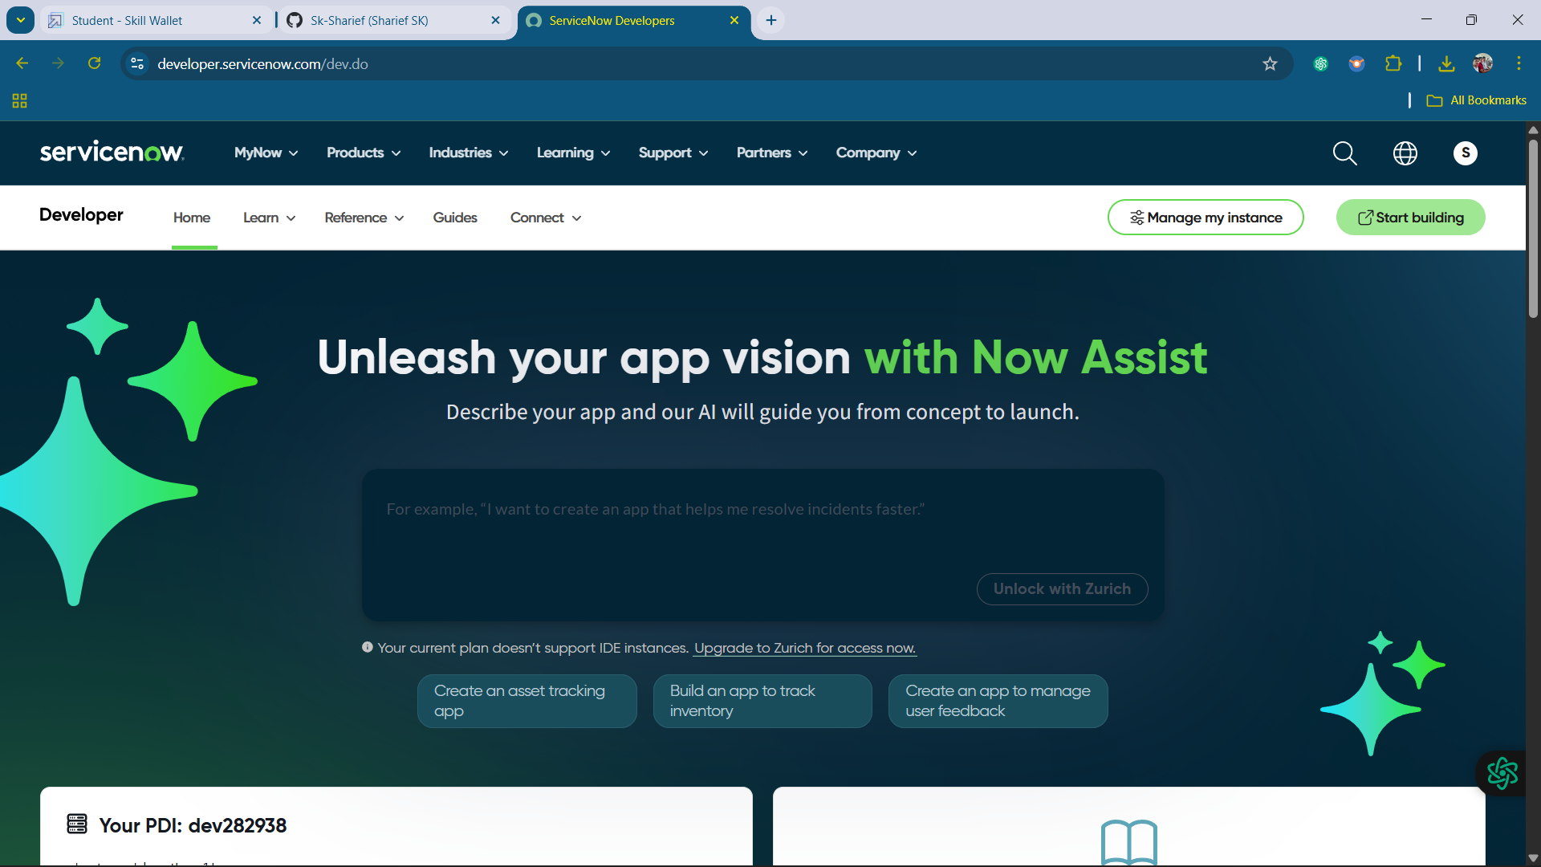

2. Creating an Update set: Education Organisation

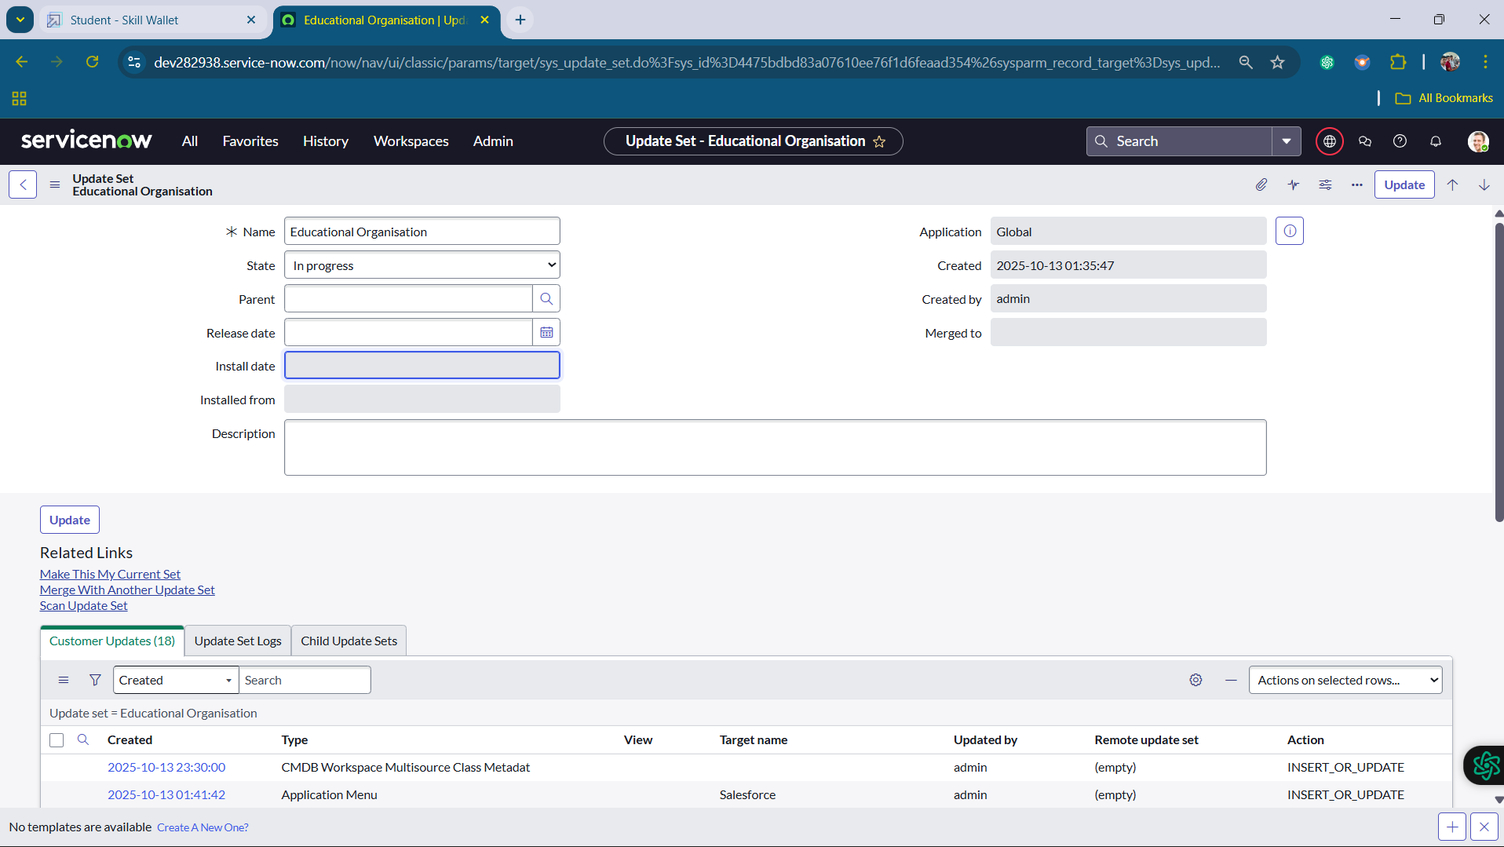

3.Creating a Table: Salesforce

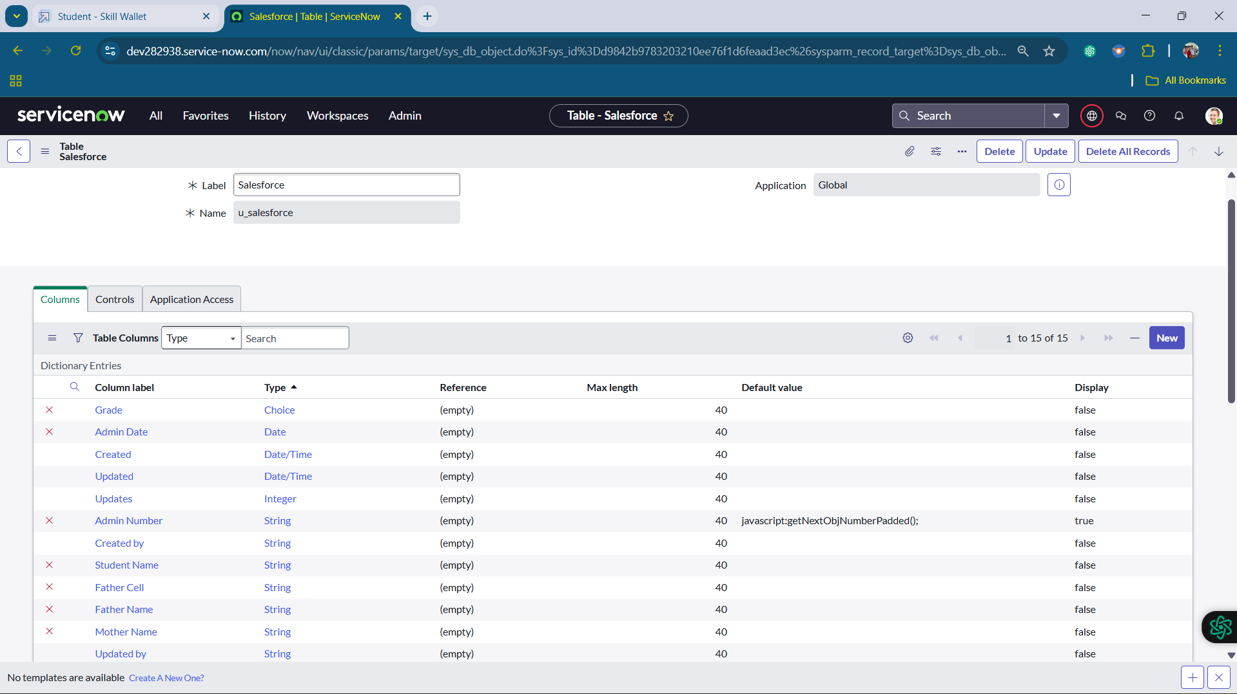

4.Creating another table: Admission table

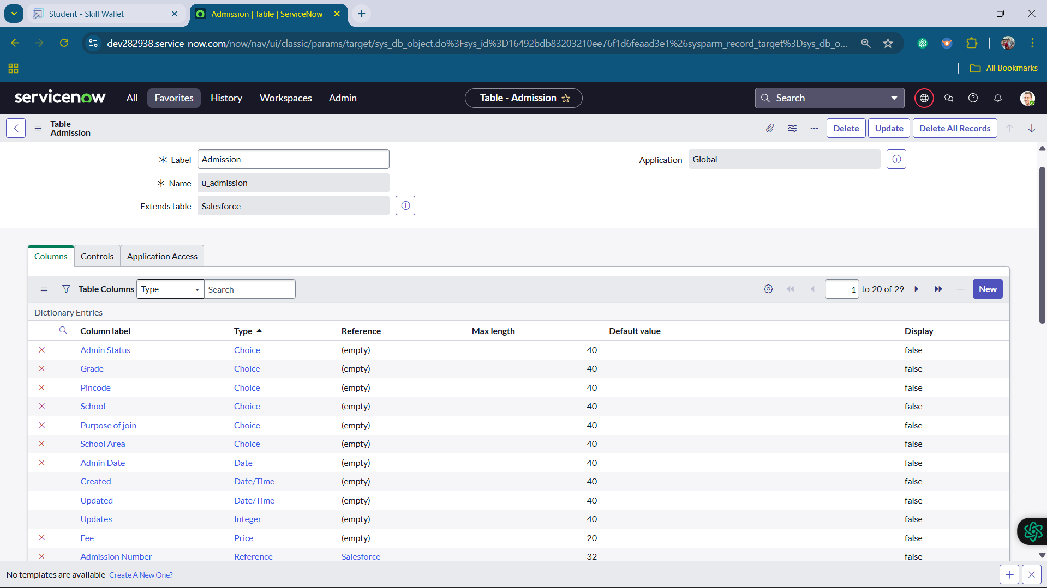

5.Creating the another table: Student Progress Table

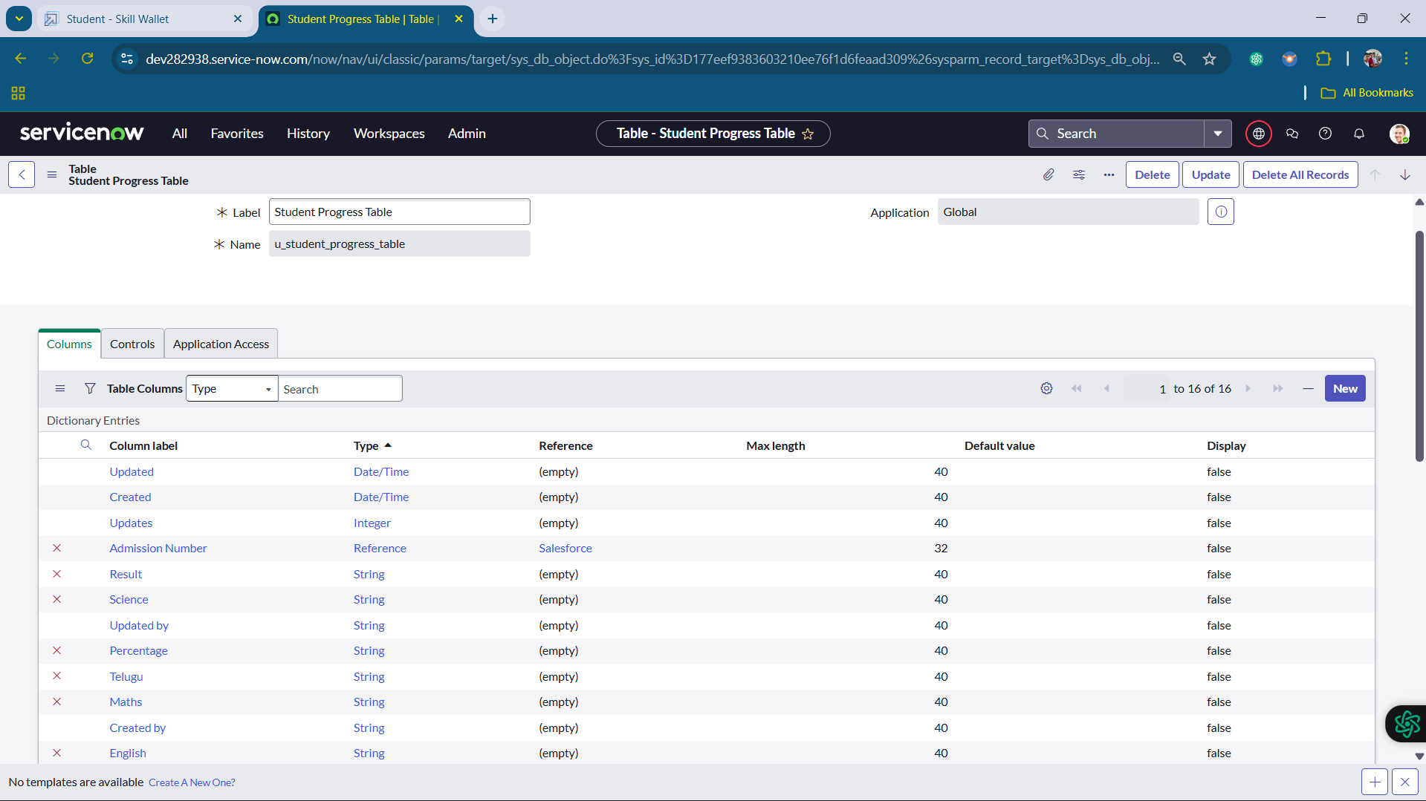

6. Configuring Table form for Student Progress Table

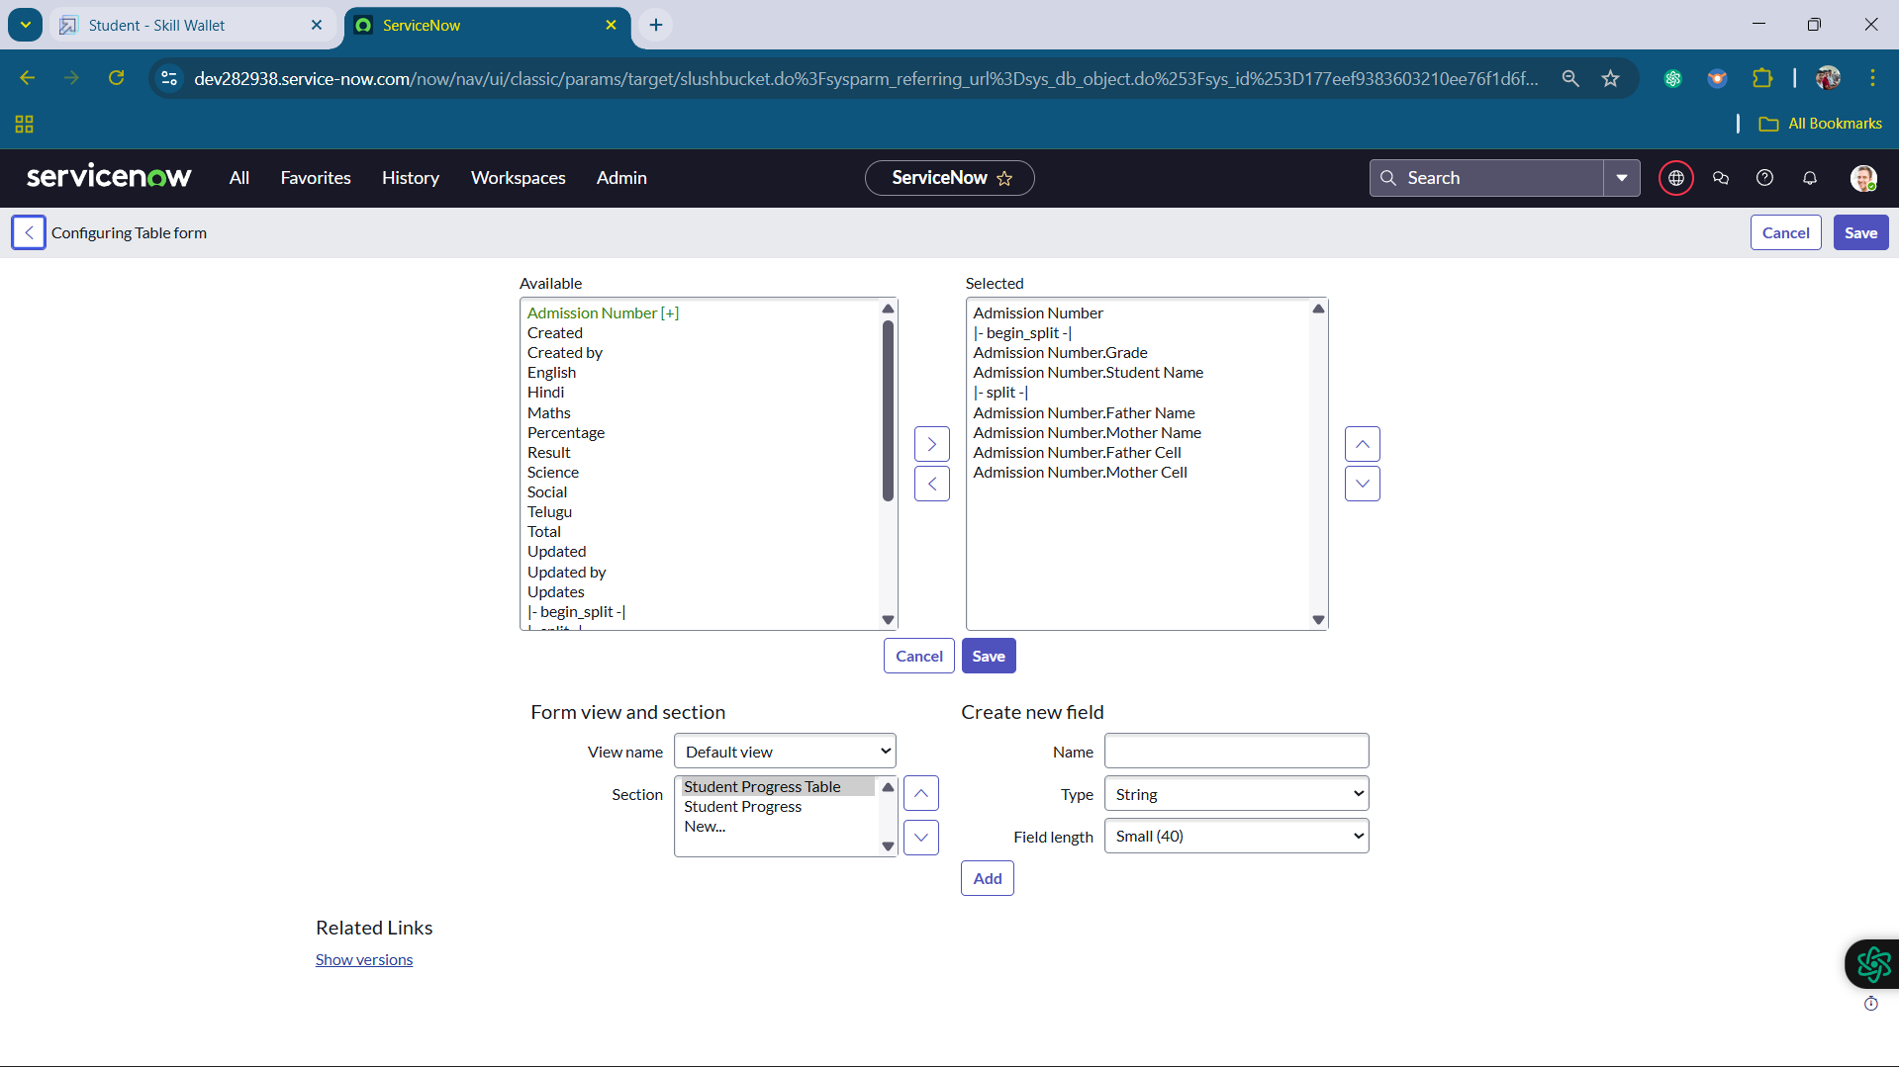

**7.** Creating Form Design for Salesforce Table

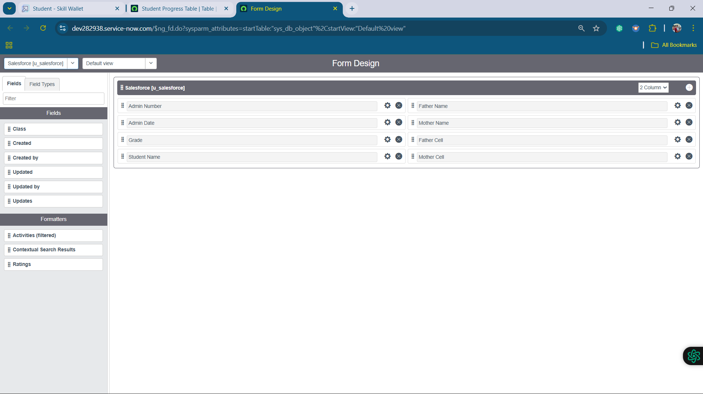

8. Creating Form Design for Admission Table

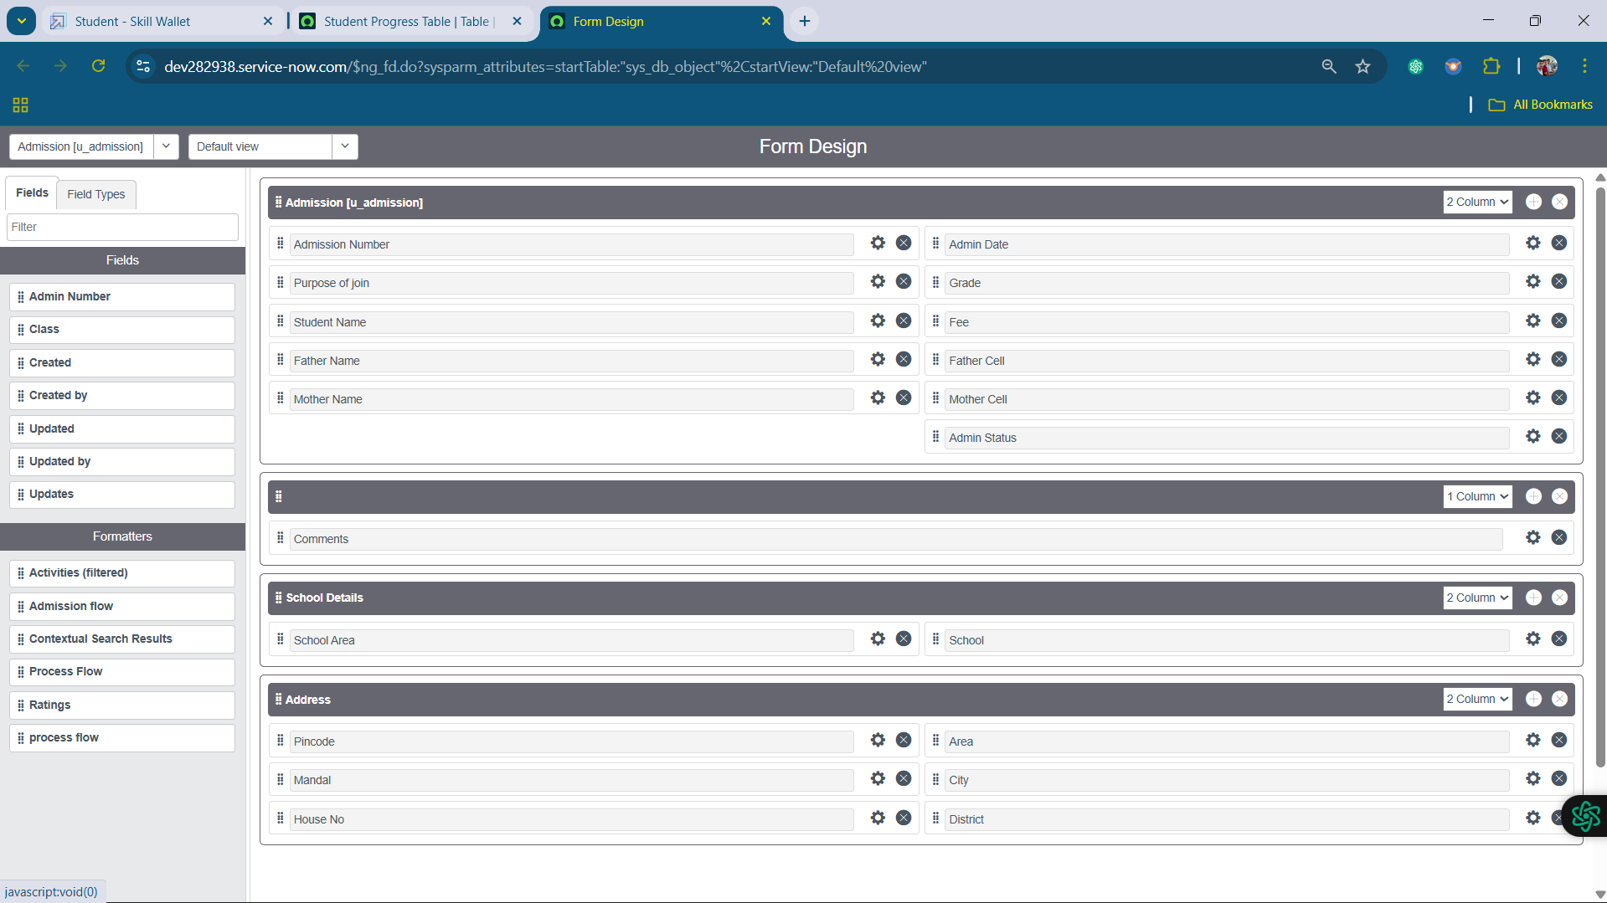

9. Creating Form Design for Student Progress Table

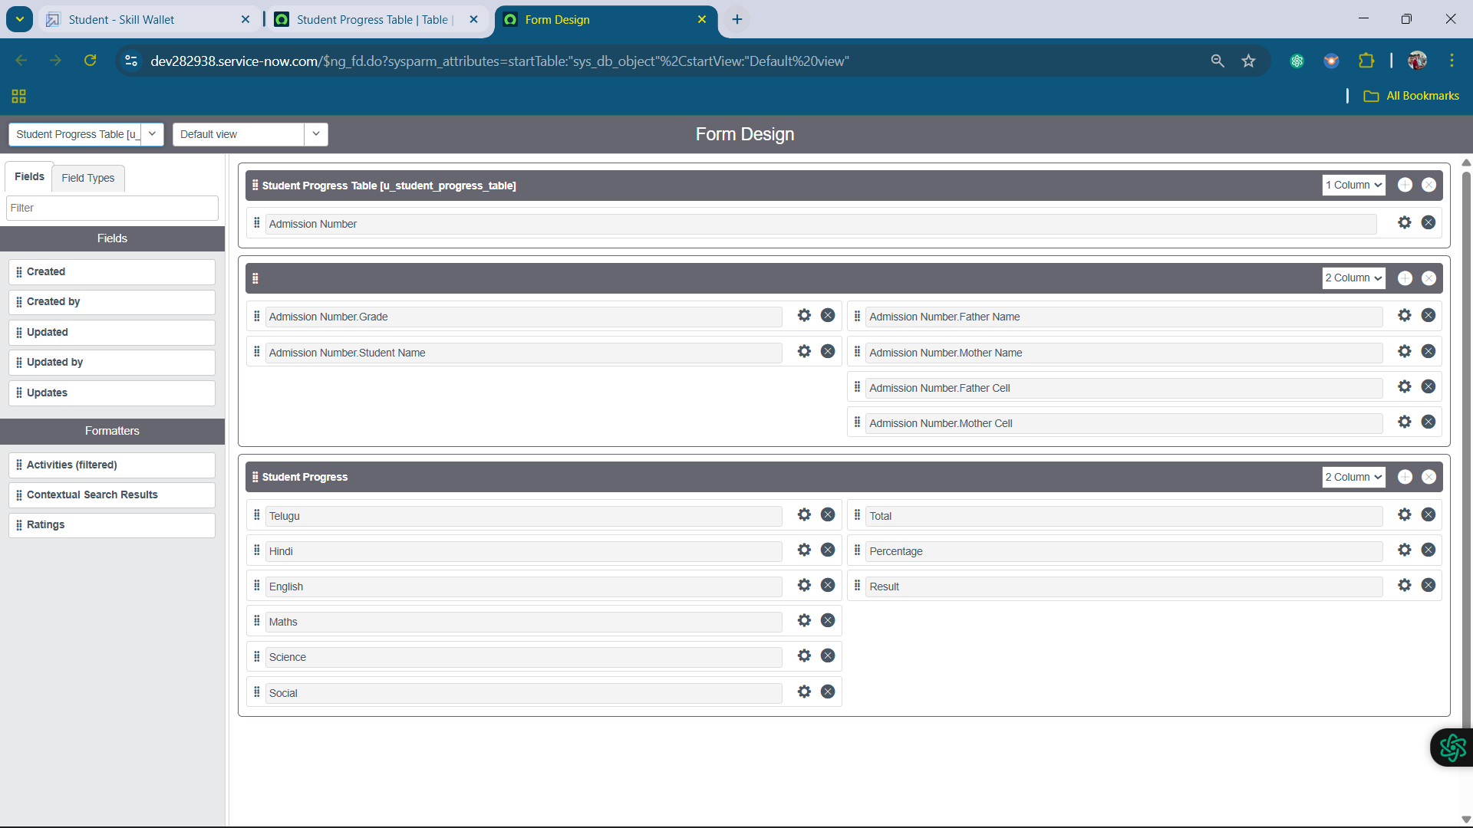

10. Creating Number Maintenance for Admin Number

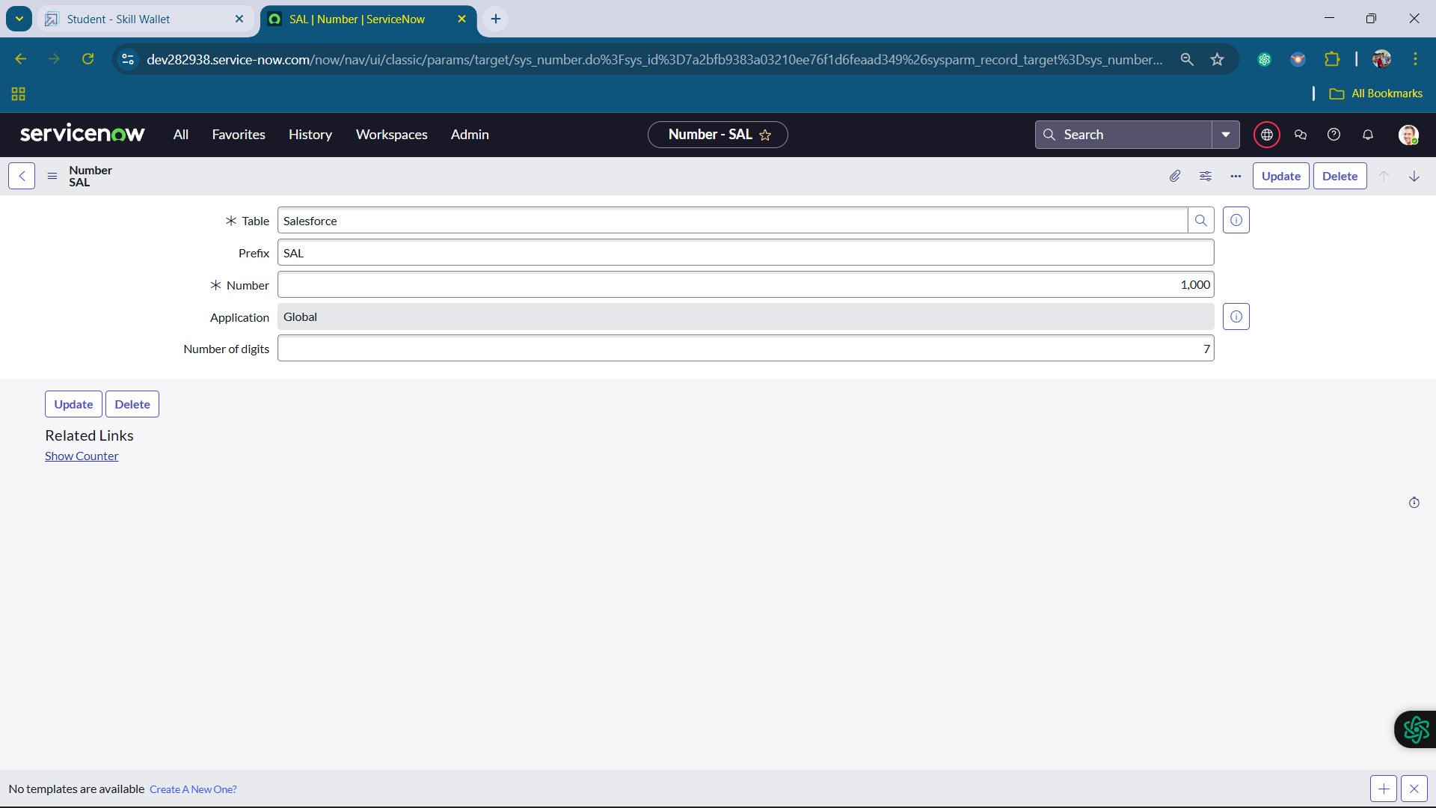

11. Creating Process Flow for Admission Table

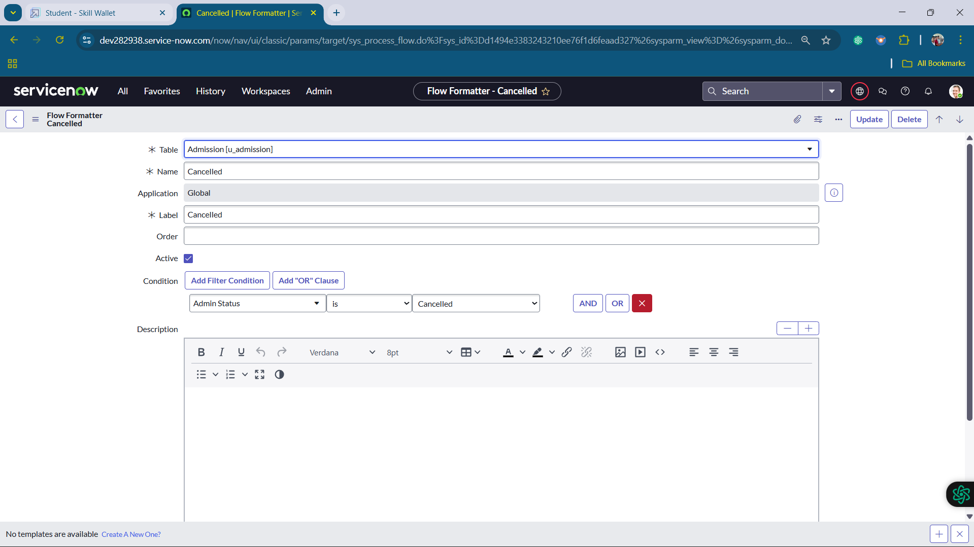

12. Creating “Auto populate” Client Scripts for Admission Table

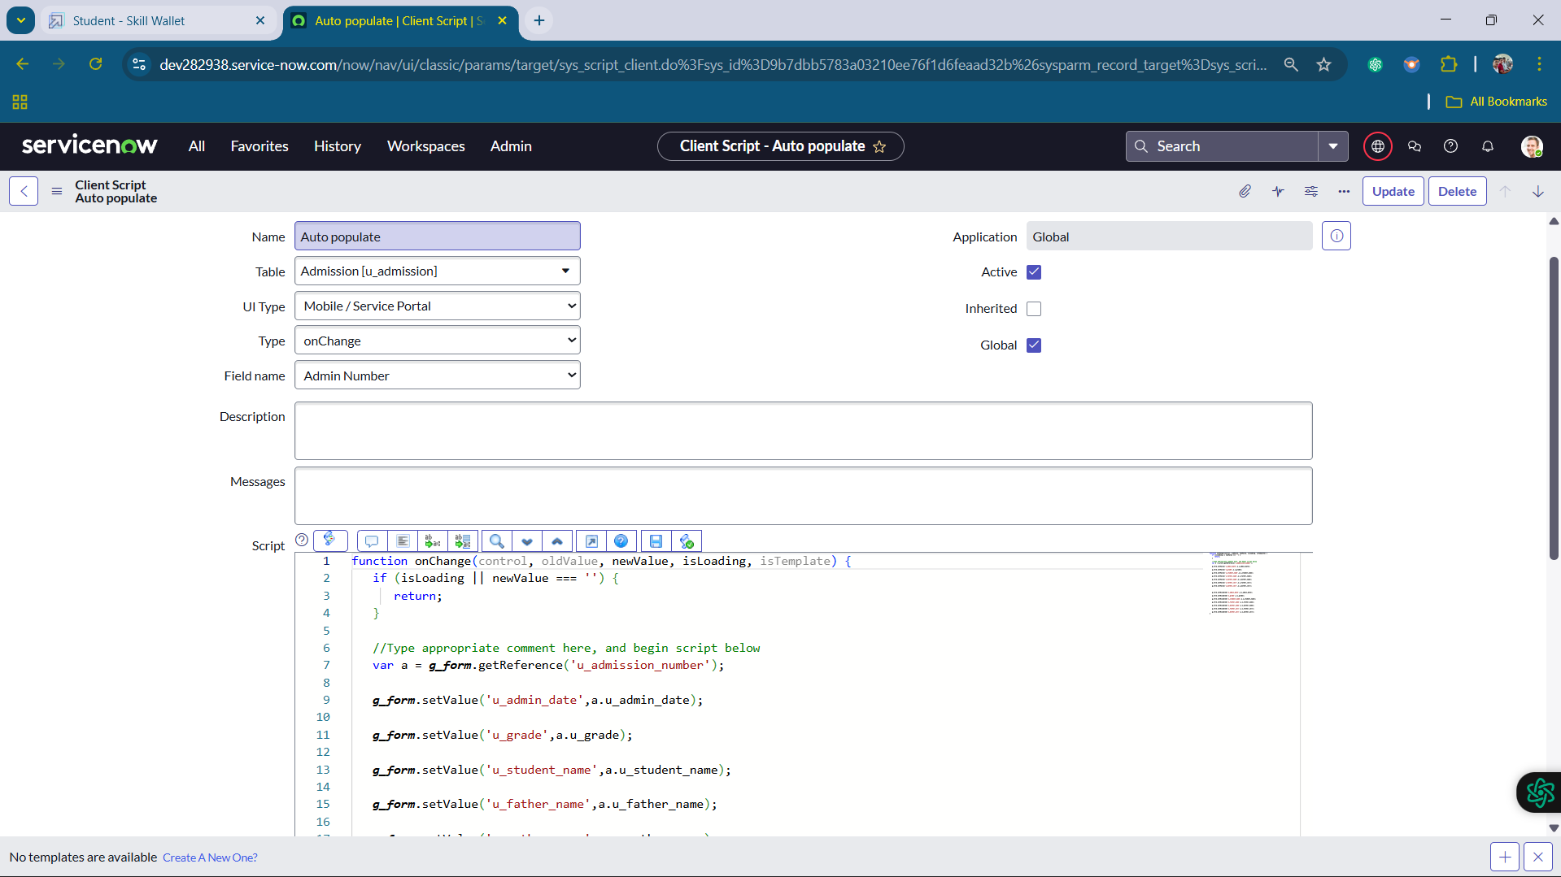

13. Creating “Pincode Update” Client Scripts for Admission Table

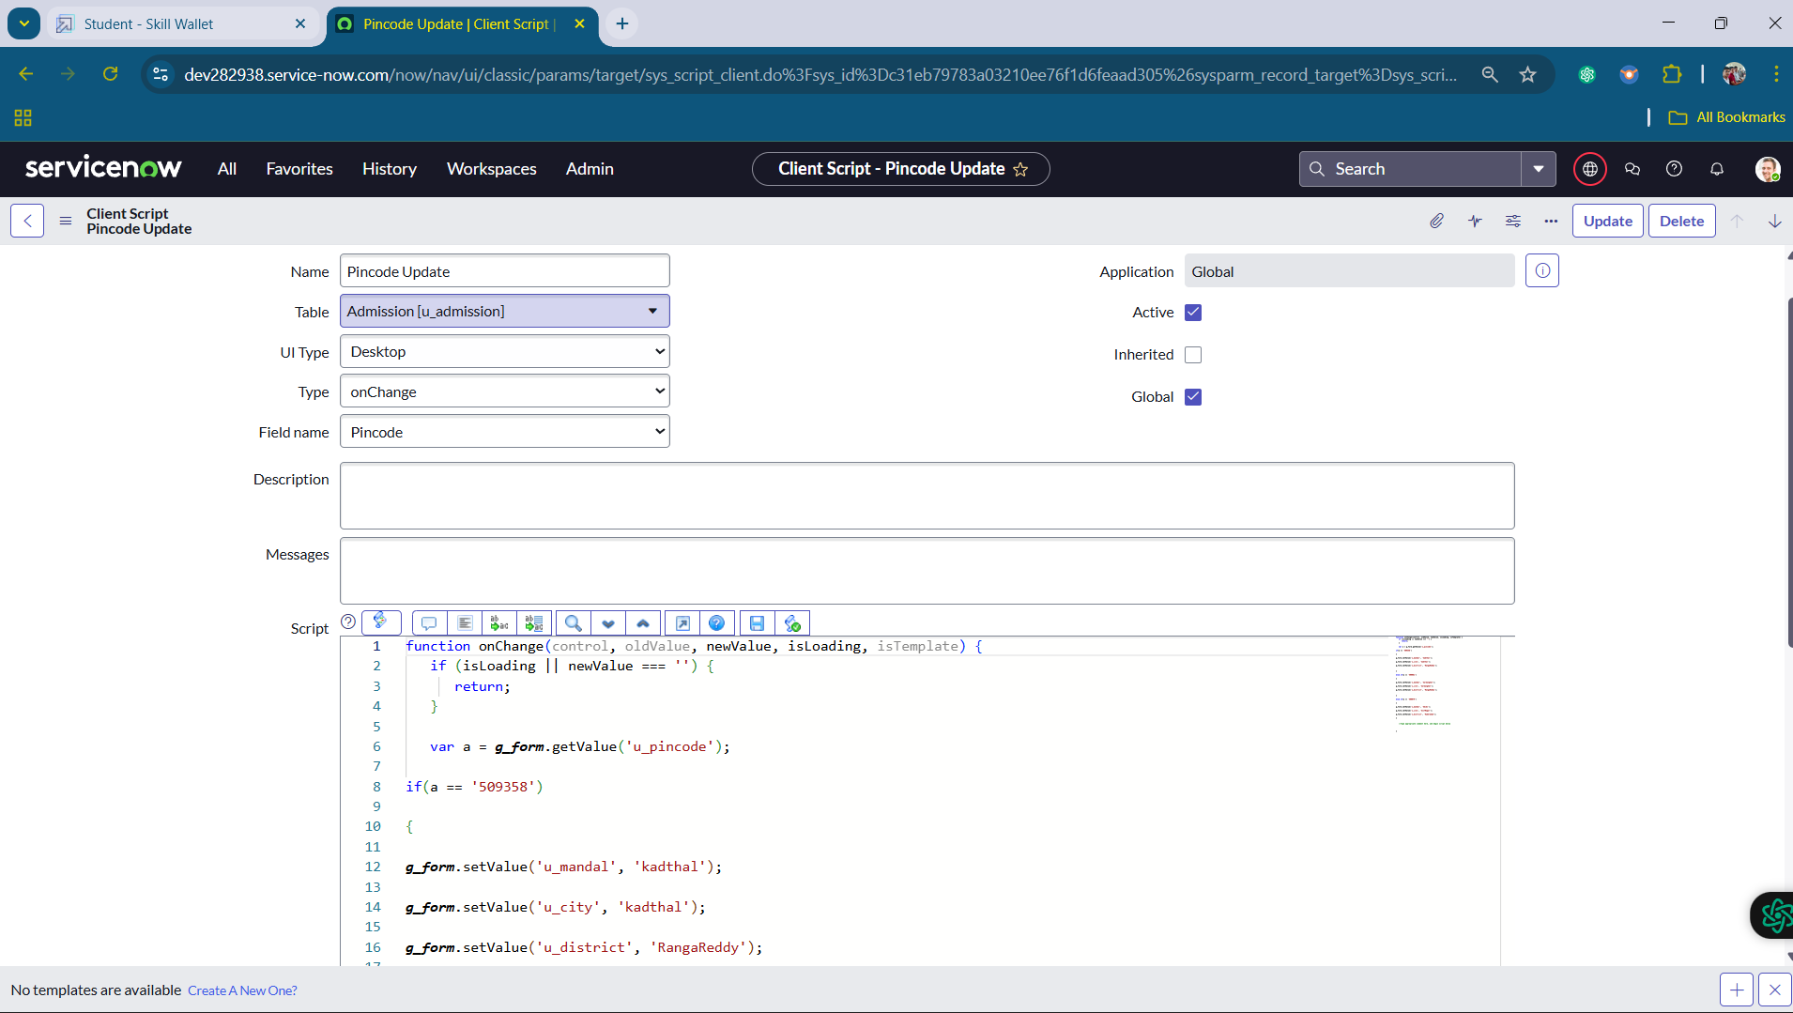

14. Creating “Disable Fields” Client Scripts for Student progress Table

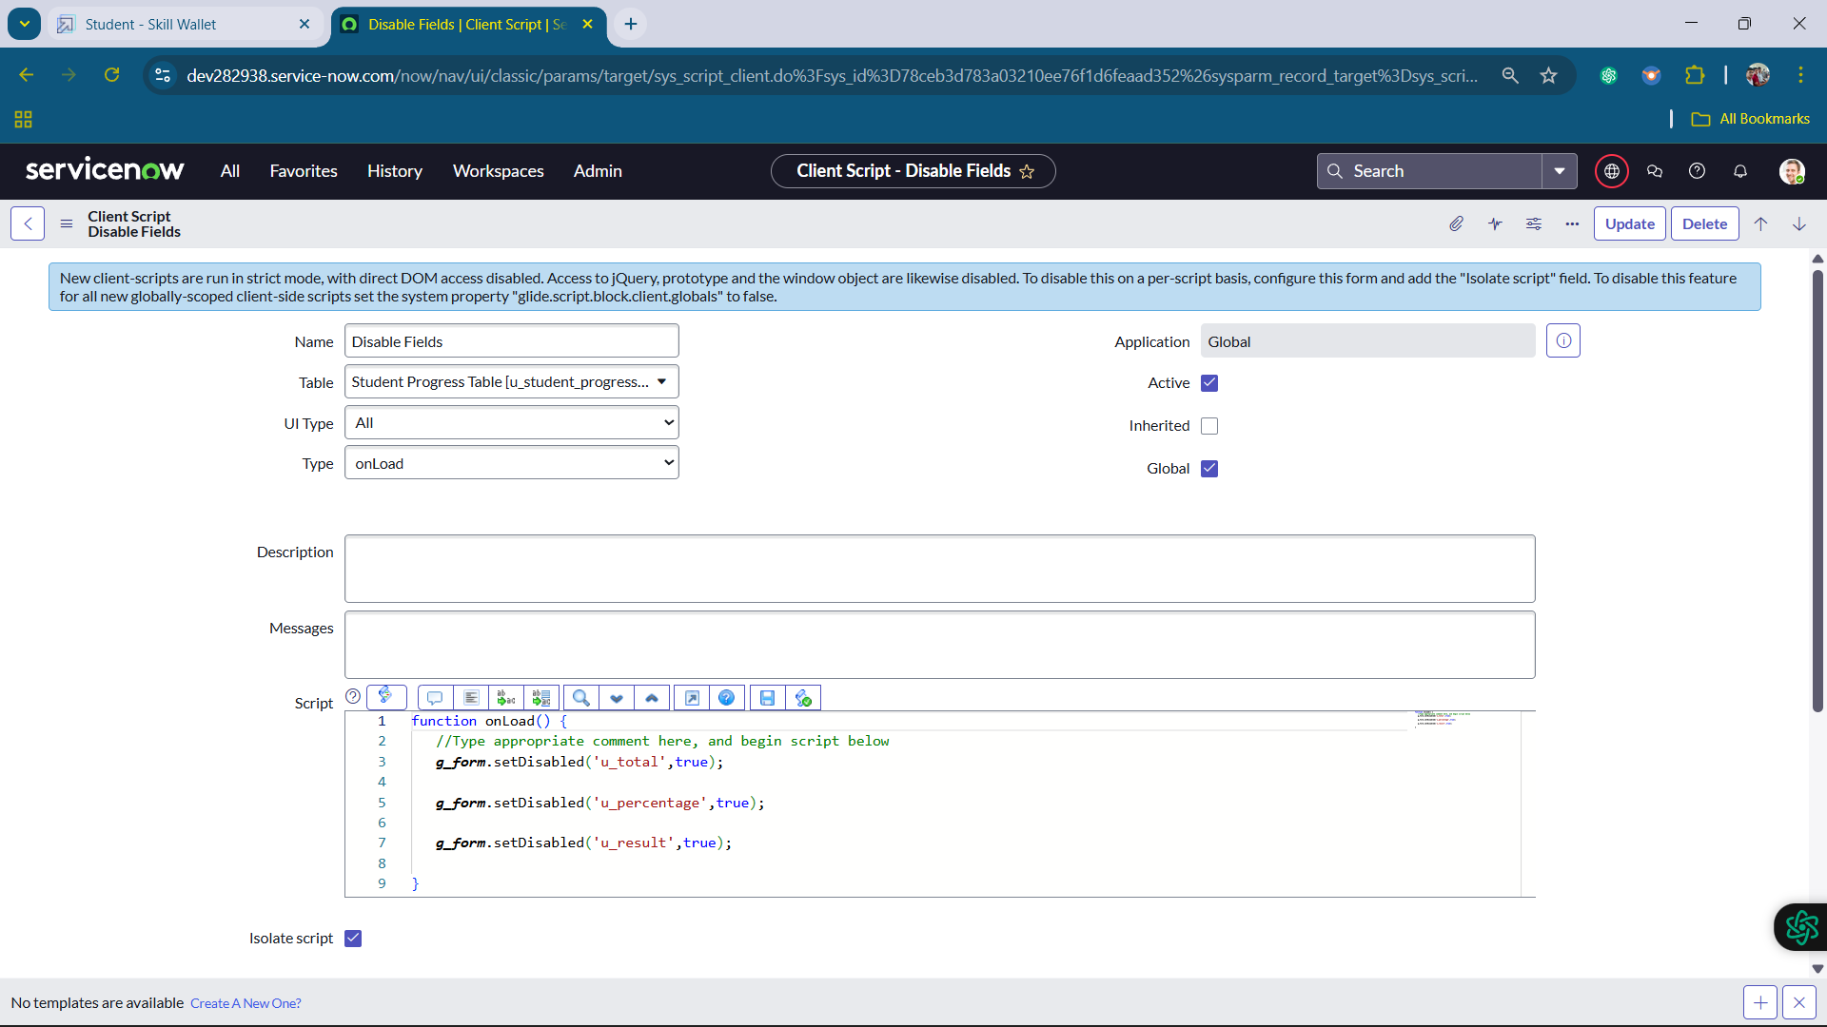

15. Creating “Total Update” Client Scripts for Student progress Table

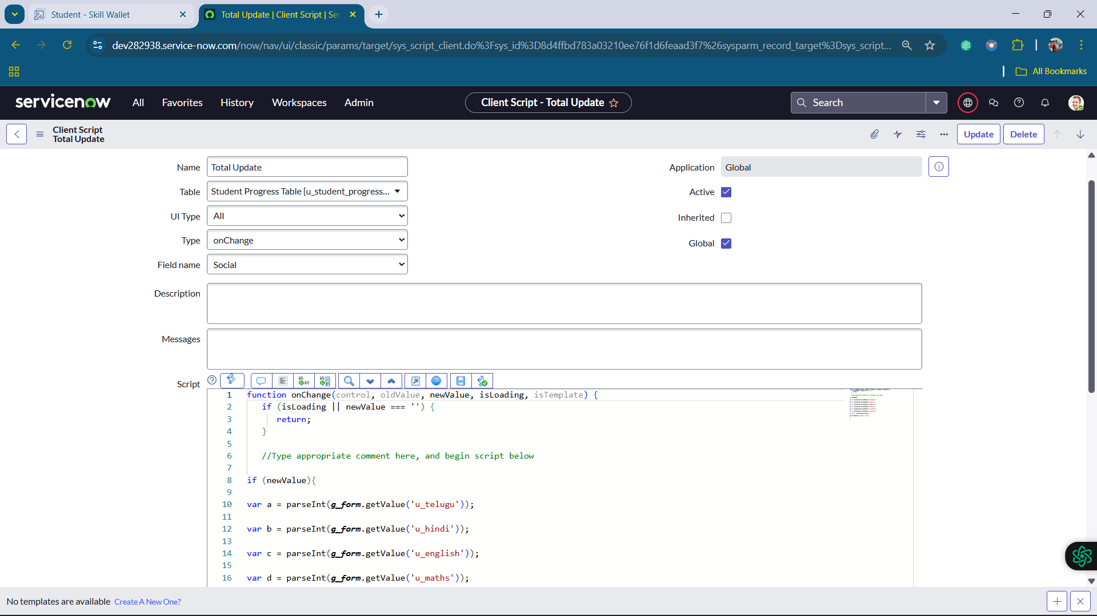

16. Creating “Result” Client Scripts for Student progress Table

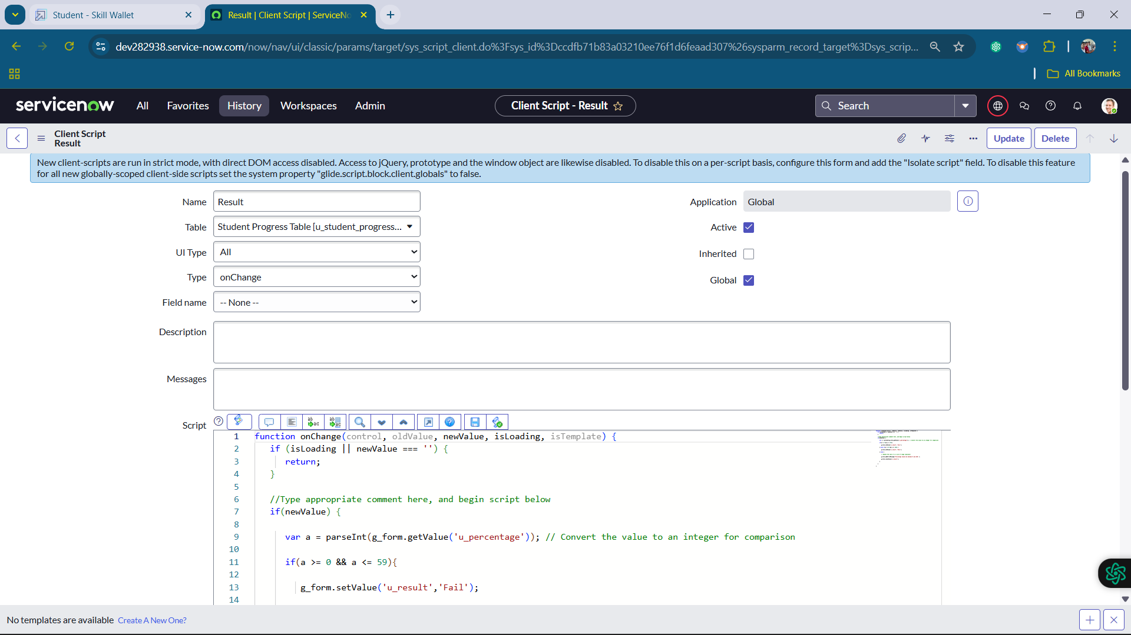

17. Creating “Percentage” Client Scripts for Student progress Table

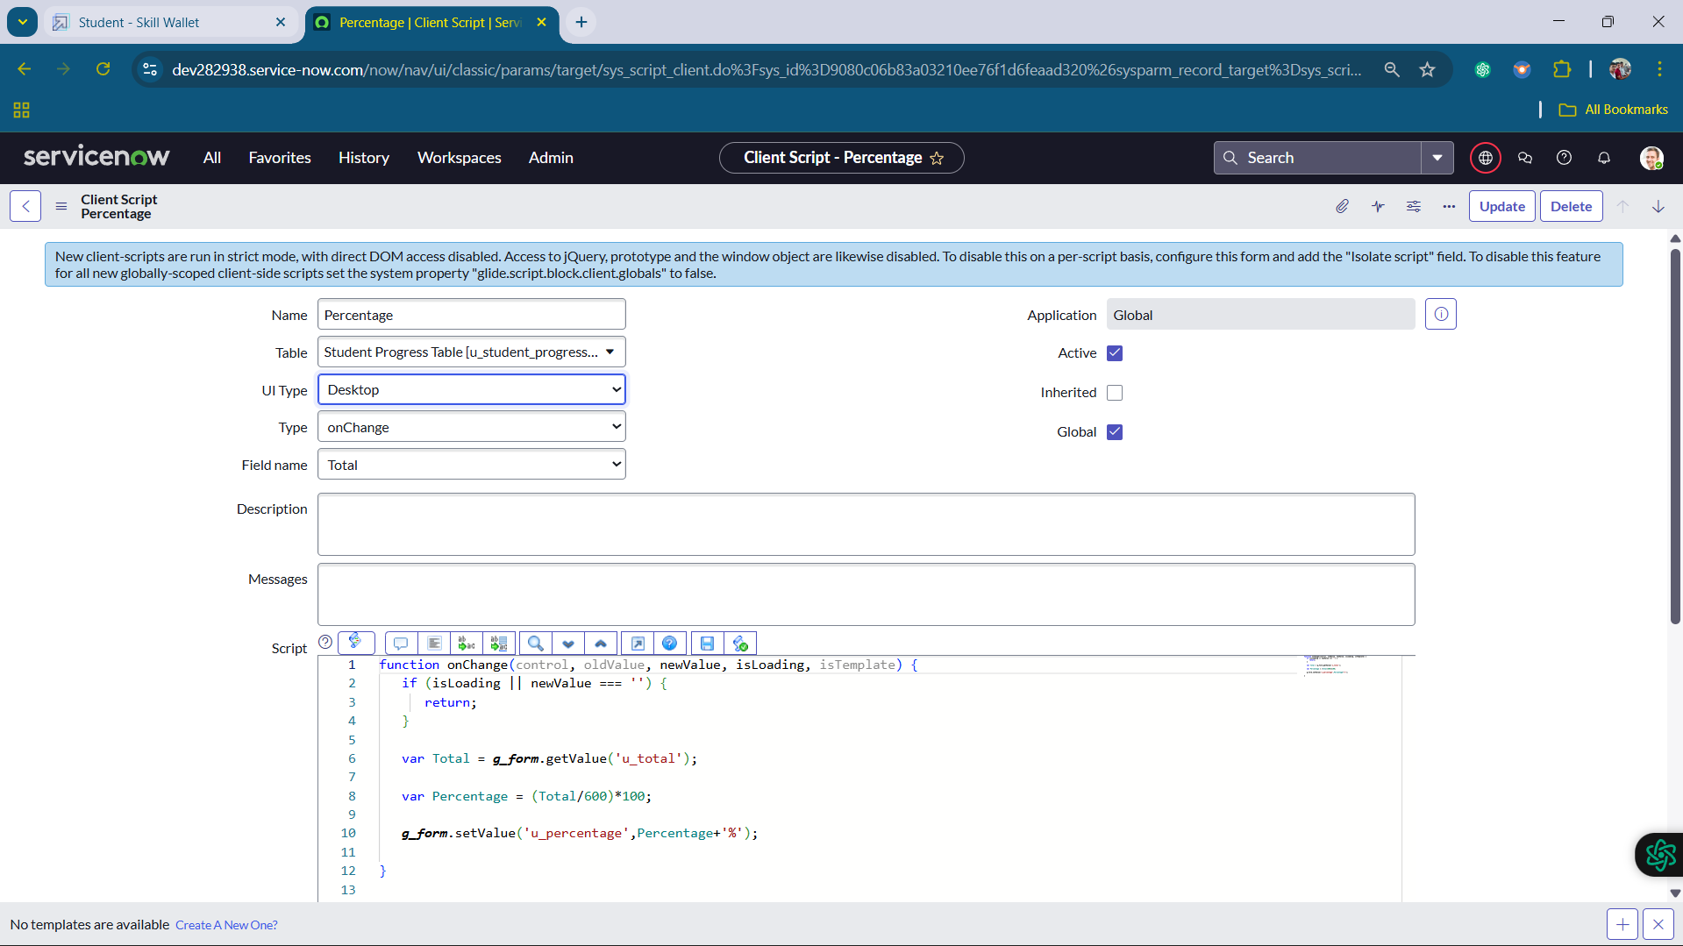

**RESULT:**

1.Salesforce record:

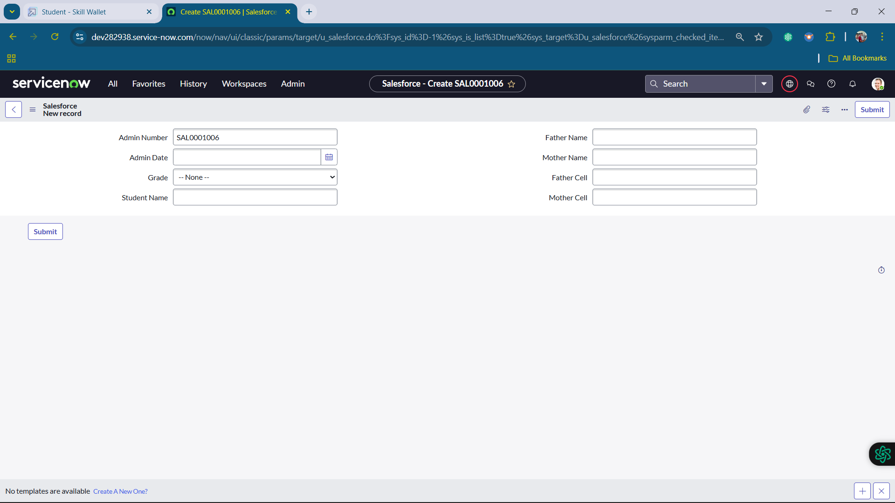

2.Admission record:

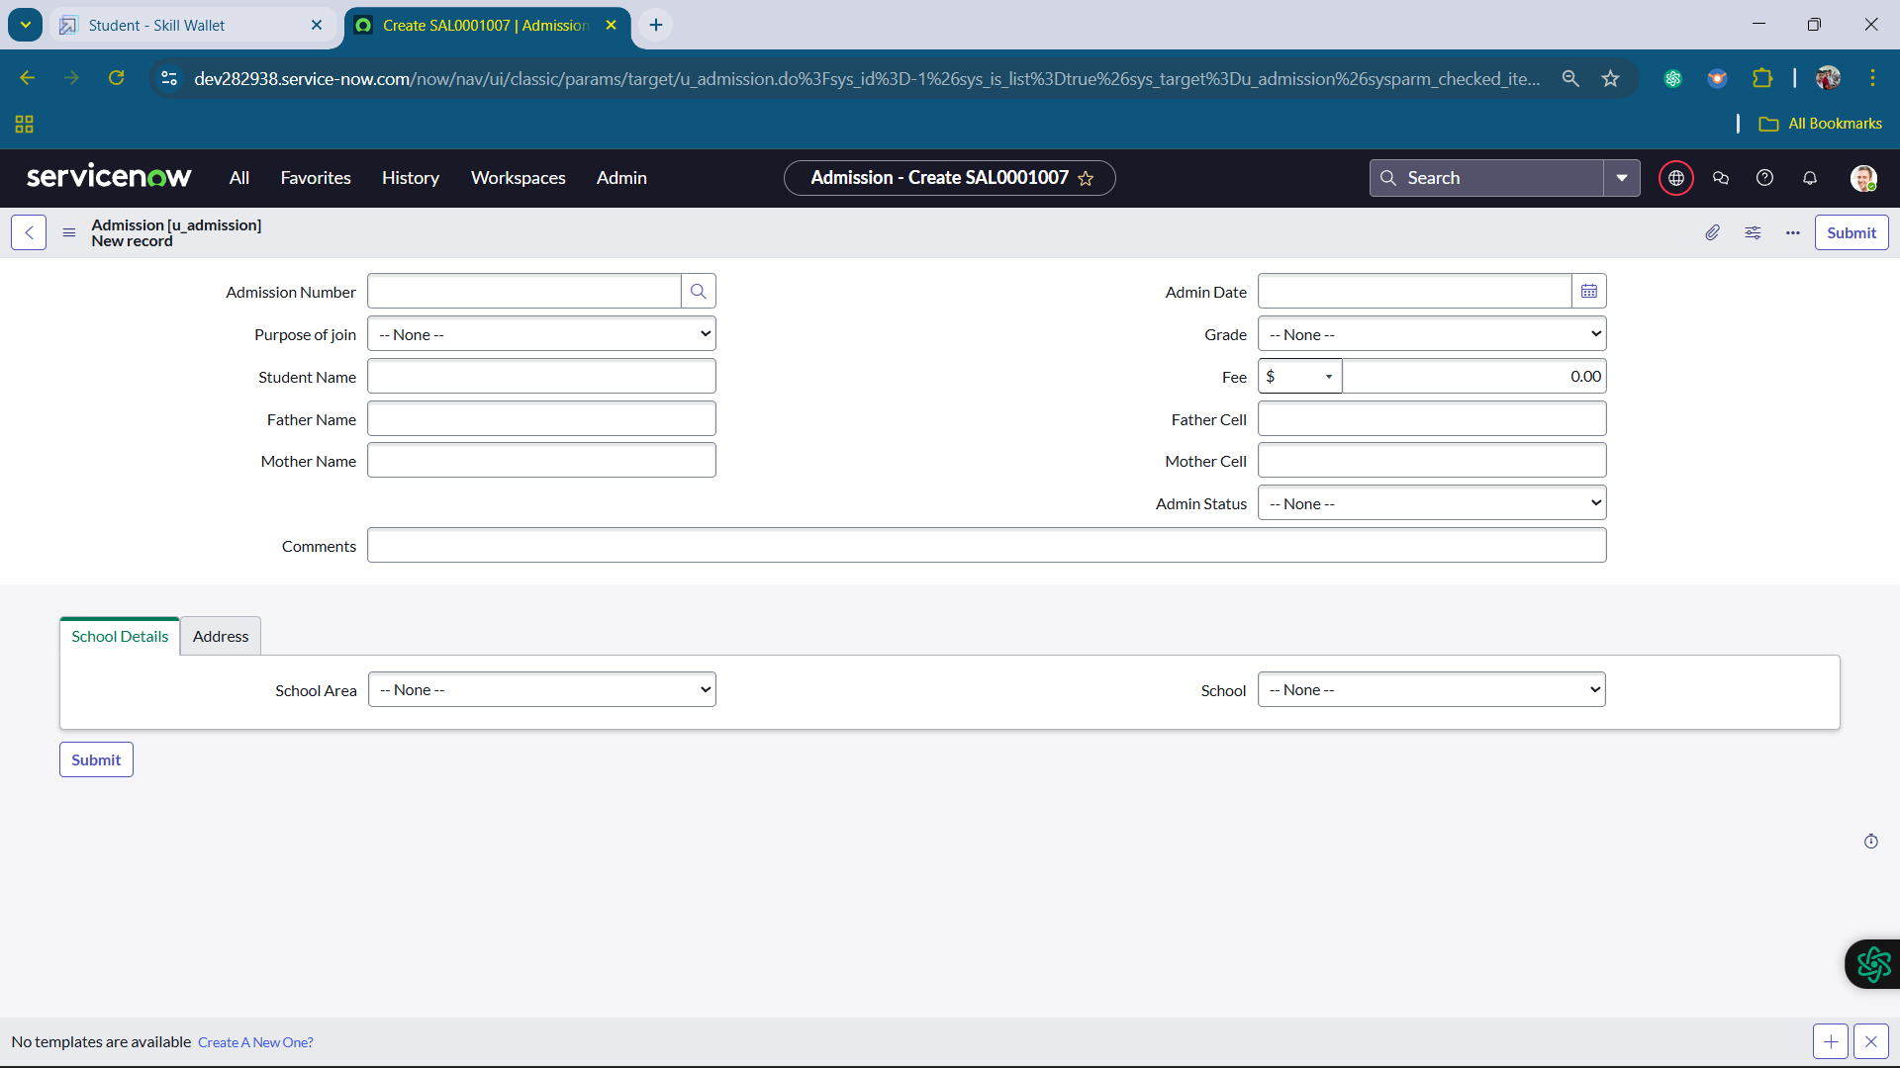

3.Student Progress Record:

